EduManage
School & Institute Management Software
A modern, easy-to-use platform to manage students, staff, academics, fees, attendance, and communication — all in one place.


Product Summary
EduManage helps schools and institutes reduce paperwork, improve accuracy, and save time by digitizing core workflows. It is designed for daily use by administrators and teachers, with clear modules for academics, operations, and reporting.

Who It’s For
- Schools (primary to senior secondary)
- Coaching centers and institutes
- School admins, principals, teachers, and office staff

Key Benefits
- Centralized records: students, teachers, classes, fees, exams, and more
- Faster daily operations: attendance, announcements, and schedules
- Better visibility: dashboard analytics and reports
- Reduced errors: standardized data entry and consistent workflows
- Export-ready: CSV/PDF outputs where applicable for sharing and printing

Core Features
- Student Management
- Register students, manage profiles, class/section, academic year, and status.
- Teacher Management
- Add and manage teacher profiles, assignments, and contact details.
- Classes & Schedule
- Maintain class/section, rooms, and weekly schedules (day/period/time/subject).
- Attendance
- Mark and edit daily attendance for students and teachers; view summaries.
- Fees
- Record fee entries, track pending/paid status, and manage fee structure by class.
- Exams & Marks
- Create exams, enter marks, and view results with filtering and exports.
- Report Cards
- Generate single or bulk report cards for printing and sharing.
- Timetables
- Add and manage timetable entries for class routines, tests, and exams.
- Announcements
- Post school-wide and class-specific notices; attachments supported for announcements.
- Salary Management
- Maintain teacher/staff salary records with paid/pending tracking.
- Settings & Audit
- Admin tools including audit log and secure snapshot exports (where enabled).

Screens (Sample)
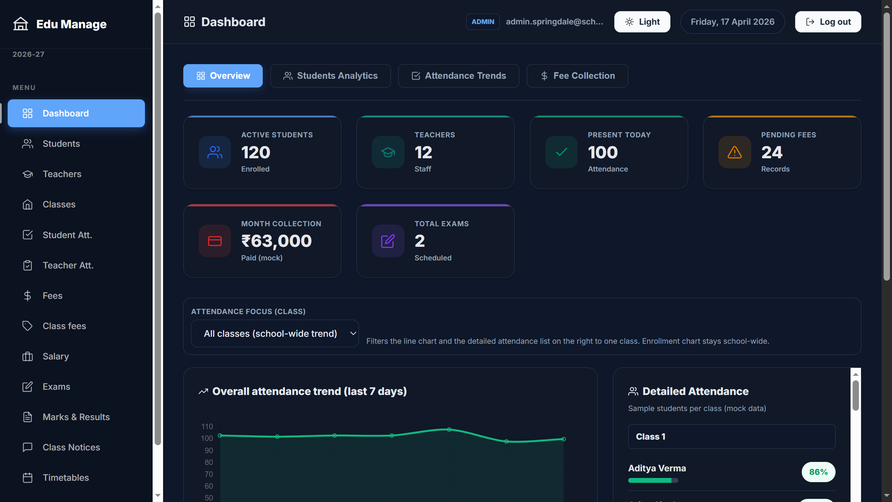
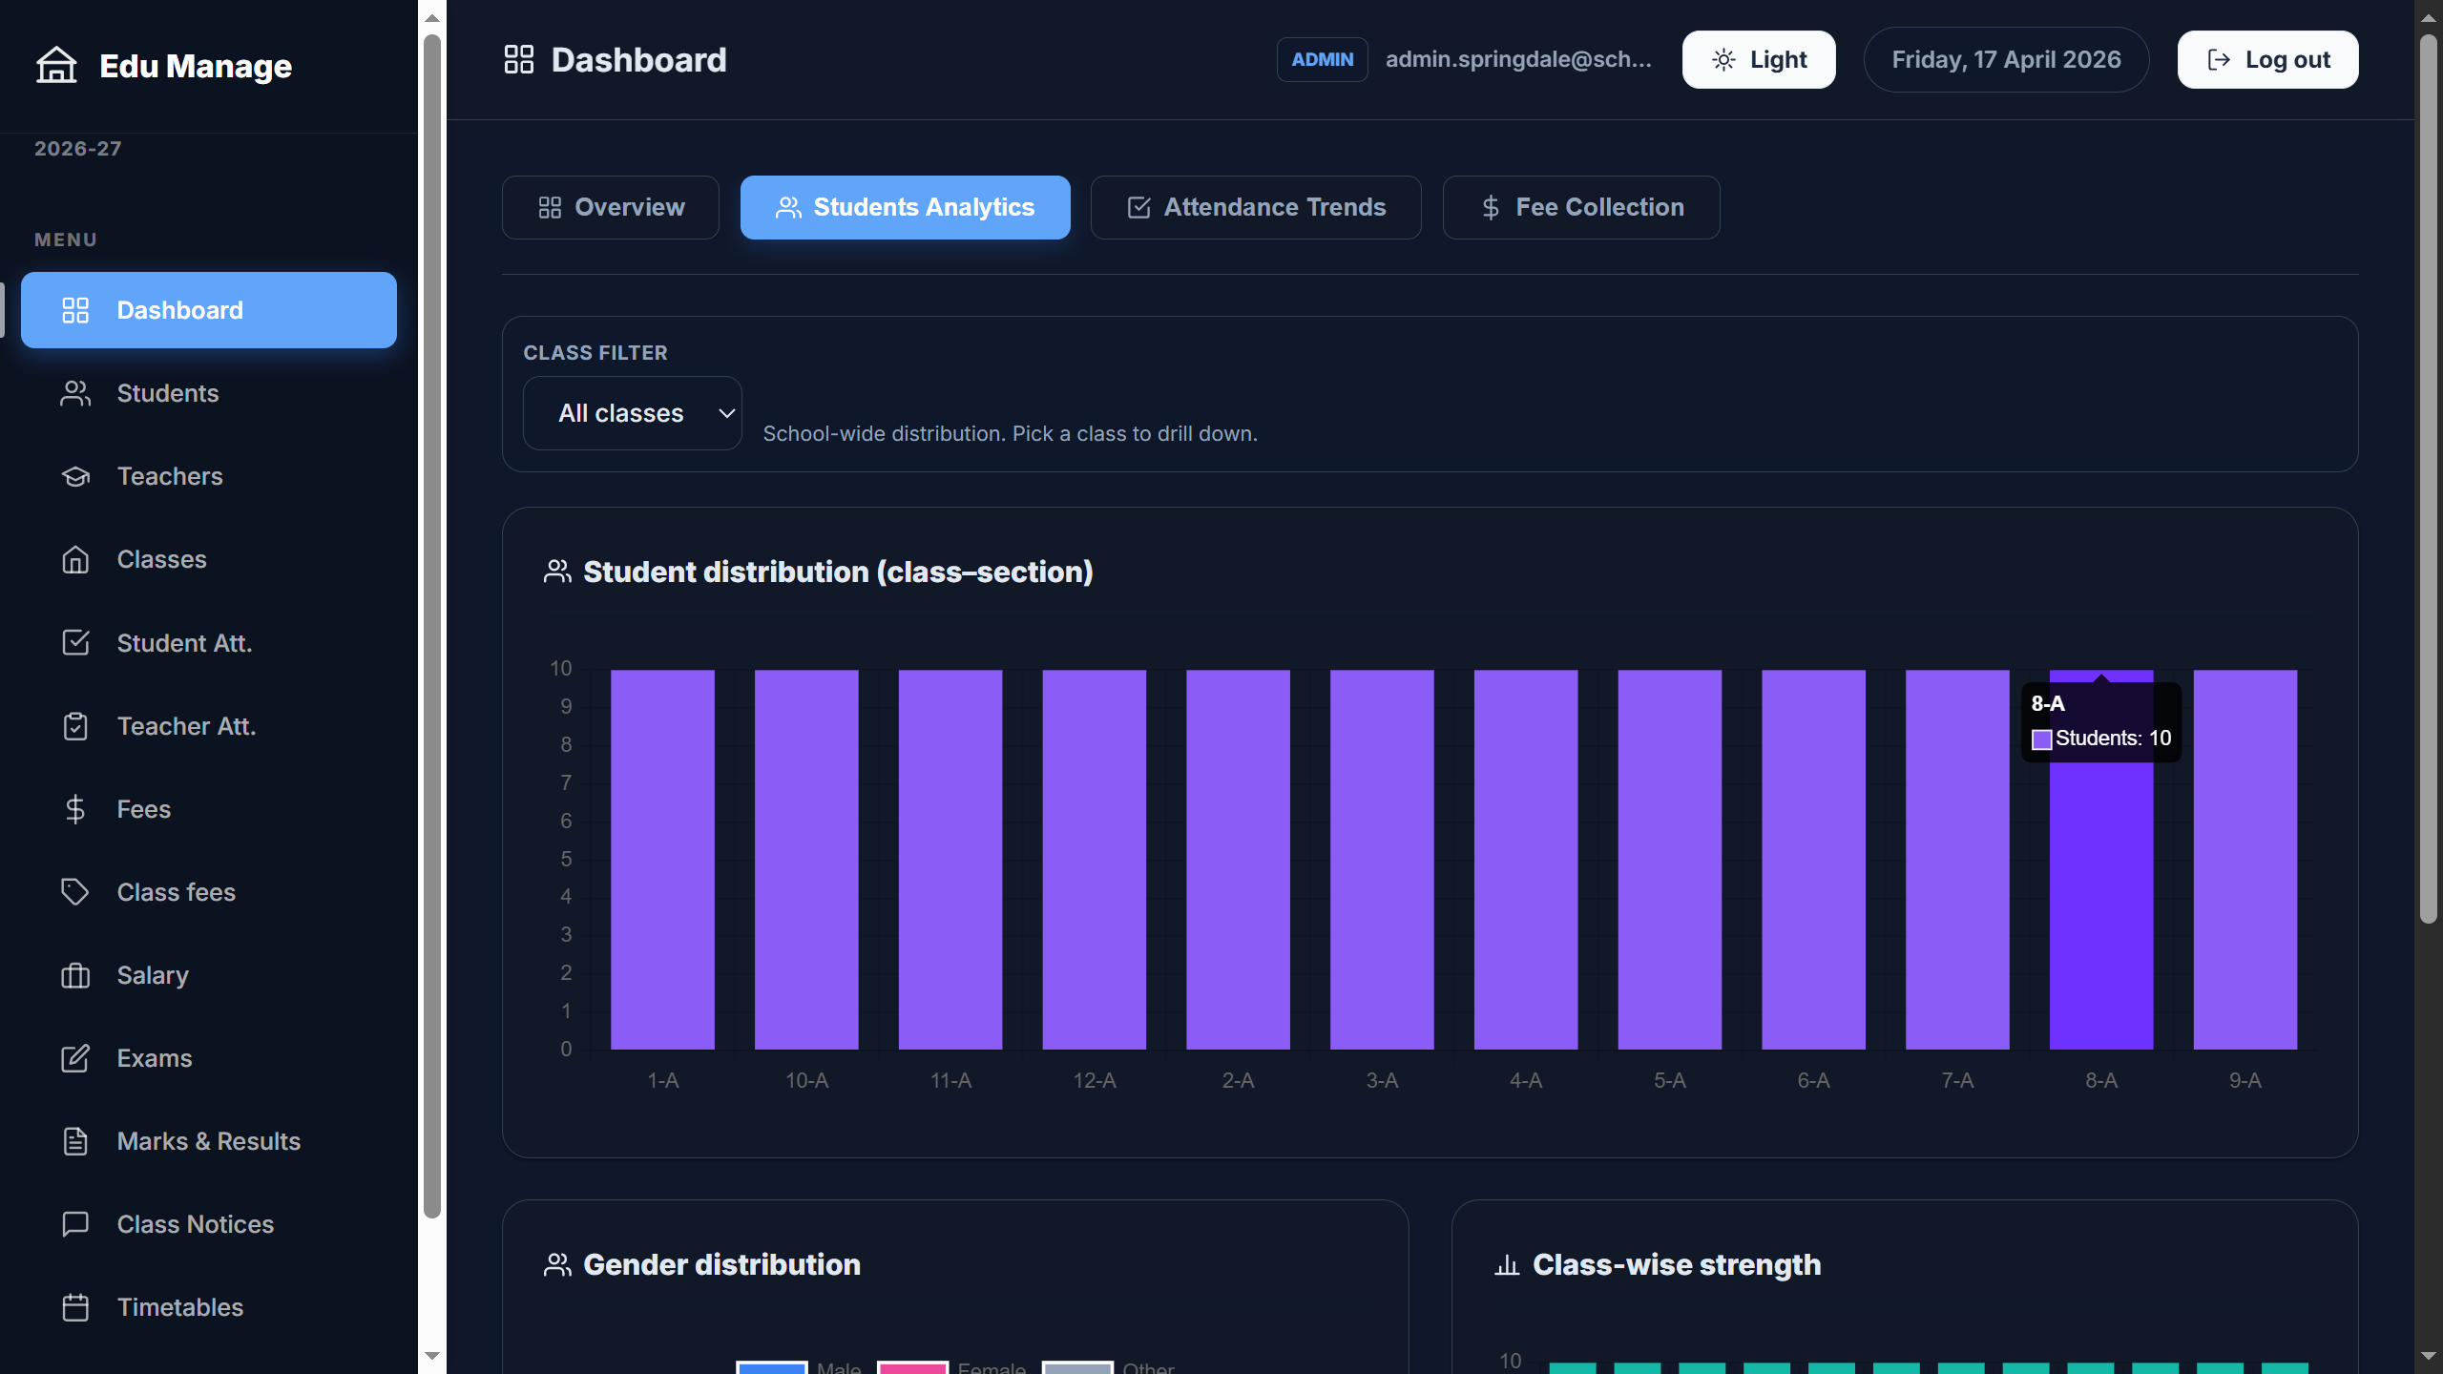
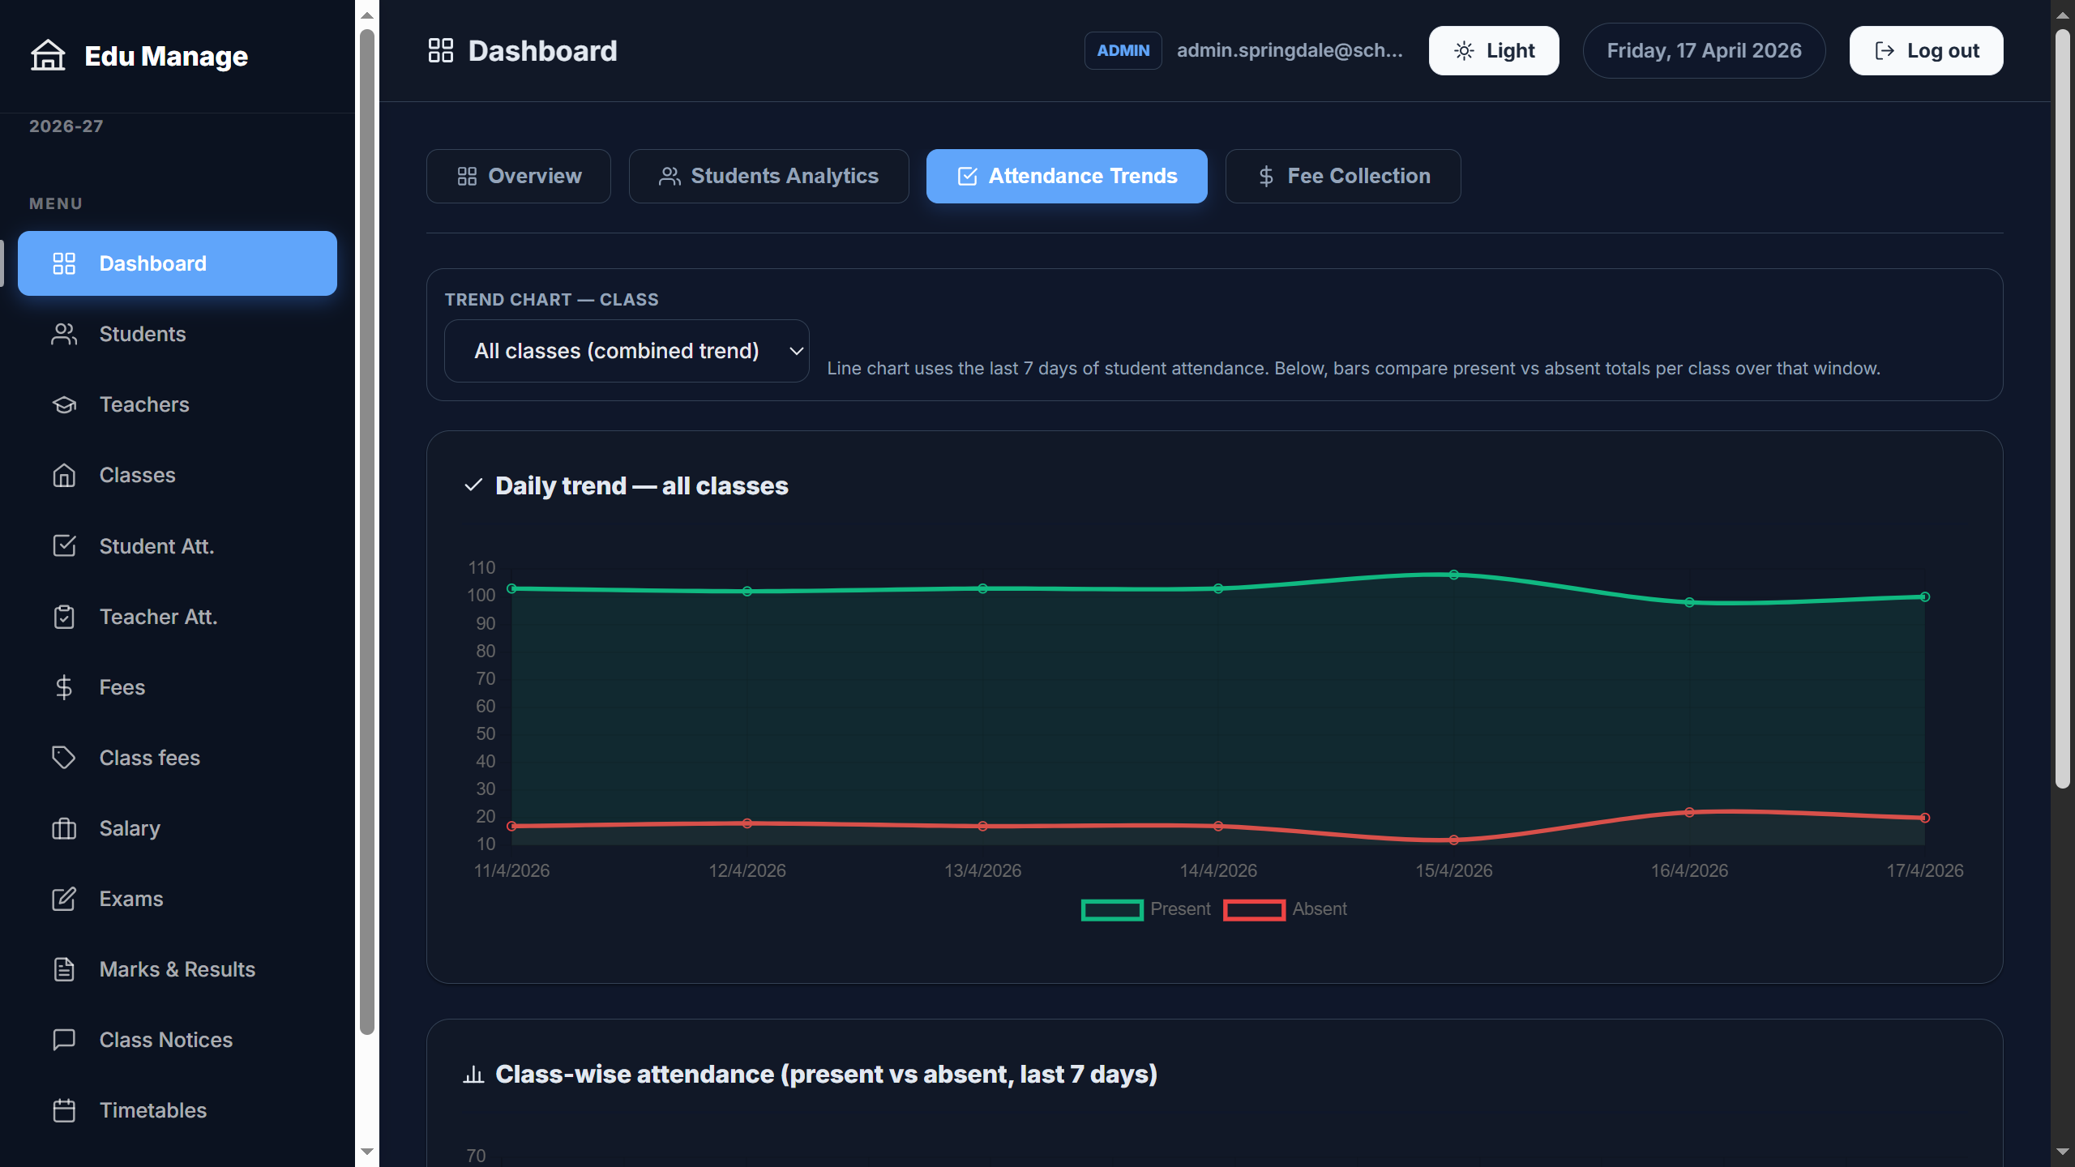

Implementation & Support (Typical)
- Requirement discussion and module selection
- Initial setup and configuration
- Data entry/import support (as required)
- Training for admin and teachers
- Ongoing support and updates

Next Steps
We can share a demo, finalize the modules you need, and provide an implementation plan based on your school size and workflow.

Contact / Proposal Details
School/Client Name: ___________________________
Prepared By: _________________________________
Date: ______________________________________

